**Project Design Phase-II**

**Technology Stack (Architecture & Stack)**

|  |  |
| --- | --- |
| Date | 03 October 2022 |
| Team ID | PNT2022TMID52627 |
| Project Name | Project – IoT enabled Smart Farming Application |
| Maximum Marks | 4 Marks |

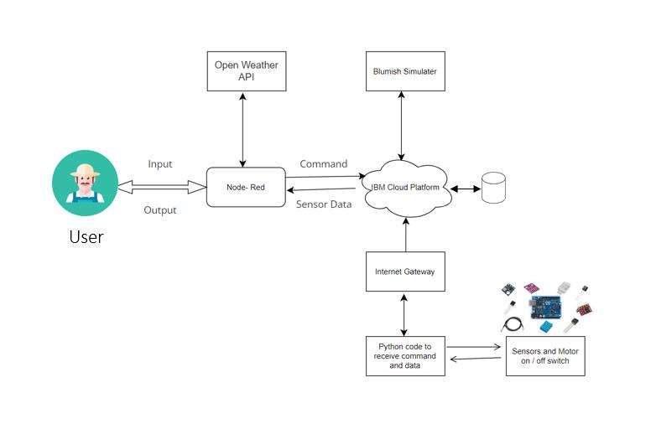

**1. The different soil parameters temperature, soil moistures and then humidity are**

**sensed using different sensors and obtained value is stored in the IBM B2 cloud.**

**2. Arduino UNO is used as a processing Unit that process the data obtained from**

**the sensors and whether data from the weather API.**

**3. NODE-RED is used as a programming tool to write the hardware, software and**

**APIs. The MQTT protocol is followed for the communication.**

**4. All the collected data are provided to the user through a mobile application that**

**was developed using the MIT app inventor. The user could make a decision**

**through an app, weather to water the field or not depending upon the sensor**

**values. By using the app they can remotely operate the motor switch.**

**Table-1 : Components & Technologies:**

|  |  |  |  |
| --- | --- | --- | --- |
| **S.No** | **Component** | **Description** | **Technology** |
|  | User Interface | How user interacts with application e.g.  Web UI, Mobile App, Chatbot etc. | HTML, CSS, JavaScript / Angular Js / React Js etc. |
|  | Application Logic-1 | Logic for a process in the application | Java / Python |
|  | Application Logic-2 | Logic for a process in the application | IBM Watson STT service |
|  | Application Logic-3 | Logic for a process in the application | IBM Watson Assistant |
|  | Database | Data Type, Configurations etc. | MySQL, NoSQL, etc. |
|  | Cloud Database | Database Service on Cloud | IBM DB2, IBM Cloudant etc. |
|  | File Storage | File storage requirements | IBM Block Storage or Other Storage Service or Local Filesystem |
|  | External API-1 | Purpose of External API used in the application | IBM Weather API, etc. |
|  | External API-2 | Purpose of External API used in the application | Aadhar API, etc. |
|  | Machine Learning Model | Purpose of Machine Learning Model | Object Recognition Model, etc. |
|  | Infrastructure (Server / Cloud) | Application Deployment on Local System / Cloud  Local Server Configuration:  Cloud Server Configuration : | Local, Cloud Foundry, Kubernetes, etc. |

**Table-2: Application Characteristic**

|  |  |  |  |
| --- | --- | --- | --- |
|  | Open-Source Frameworks | List the open-source frameworks used | Technology of Opensource framework |
|  | Security Implementations | Sensitive and private datamust be protected from their productionuntildecision-making and storage stages. | Node-Red,  Open weather App API,MIT App Inventor |
|  | Scalable Architecture | Scalability is a major  concern for IoT platforms. It has been  different  shown  that  architectural  choices of IoT platforms  affect system scalability and  that automatic real time  decision-making is feasible  in  an  environment  composed of dozens of  thousand. | Technology used |
|  |  |  |  |
|  |  |  |  |